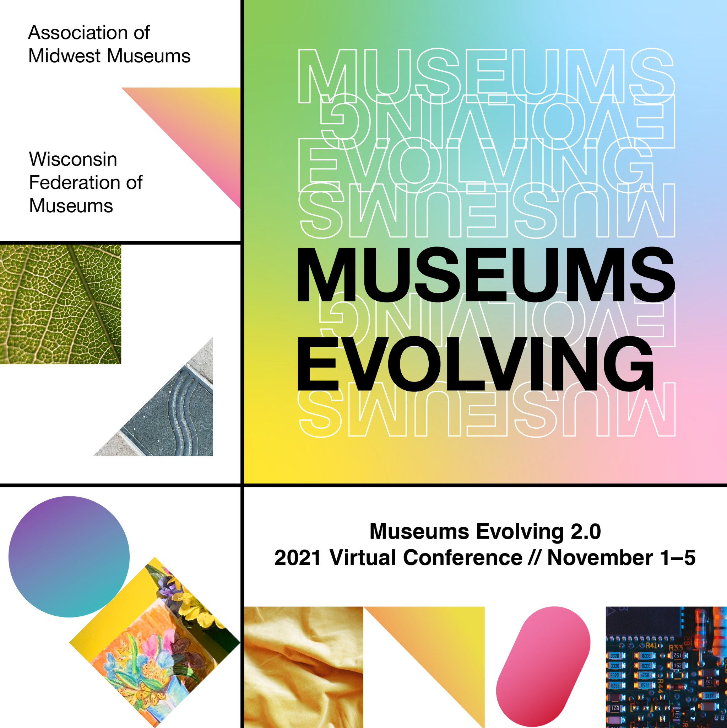

Call for Expo Proposals

Museums Evolving 2.0
2021 Virtual Conference // November 1-5
ammconference.org
-Deadline: July 30, 2021-

About the Virtual Expo
Our 2021 Virtual Conference - Museums Evolving 2.0 - will include both on-demand and live opportunities. Conference sessions and activities will be accessed via an online platform. One of the features of the conference will be the Museums Evolving 2.0 Virtual Expo highlighting museums and service providers in our community. Museum features in the expo may include video, text descriptions, photos, and website links.

Participants will have access to the virtual expo in advance of the live conference and for up to 3 months following the live event. During the live event, attendees will be able to find and enter prize drawings hidden within the expo.

We are excited to showcase the work of museums of all types and sizes!

Propose a Feature for the Expo
Members of the Association of Midwest Museums or Wisconsin Federation of Museums may submit proposals for the Museums Evolving 2.0 Virtual Expo. We encourage you to feature a recent project or initiative, exhibition, program, your collections, or a story about your museum that you feel will be of interest to your peers. What would you like to highlight? No museum feature is too big or too small!

To qualify, museums must:
- Be a current/active member in either AMM or WFM.
- Submit a completed submission form with all required content and materials.

What you will need to provide:
- Contact Information - please list the individual responsible for your expo feature
- Confirmation of your membership in either AMM or WFM
- Background information on your museum (250 words maximum)
- Description of your feature (500 words maximum)
- Link to your museum’s website
- Link to a webpage with more information about your project, etc.
- Video link
- Your museum’s logo
- Up to 3 photos/ images associated with your feature (minimum of one)

Submit your proposal online by July 30, 2021.

