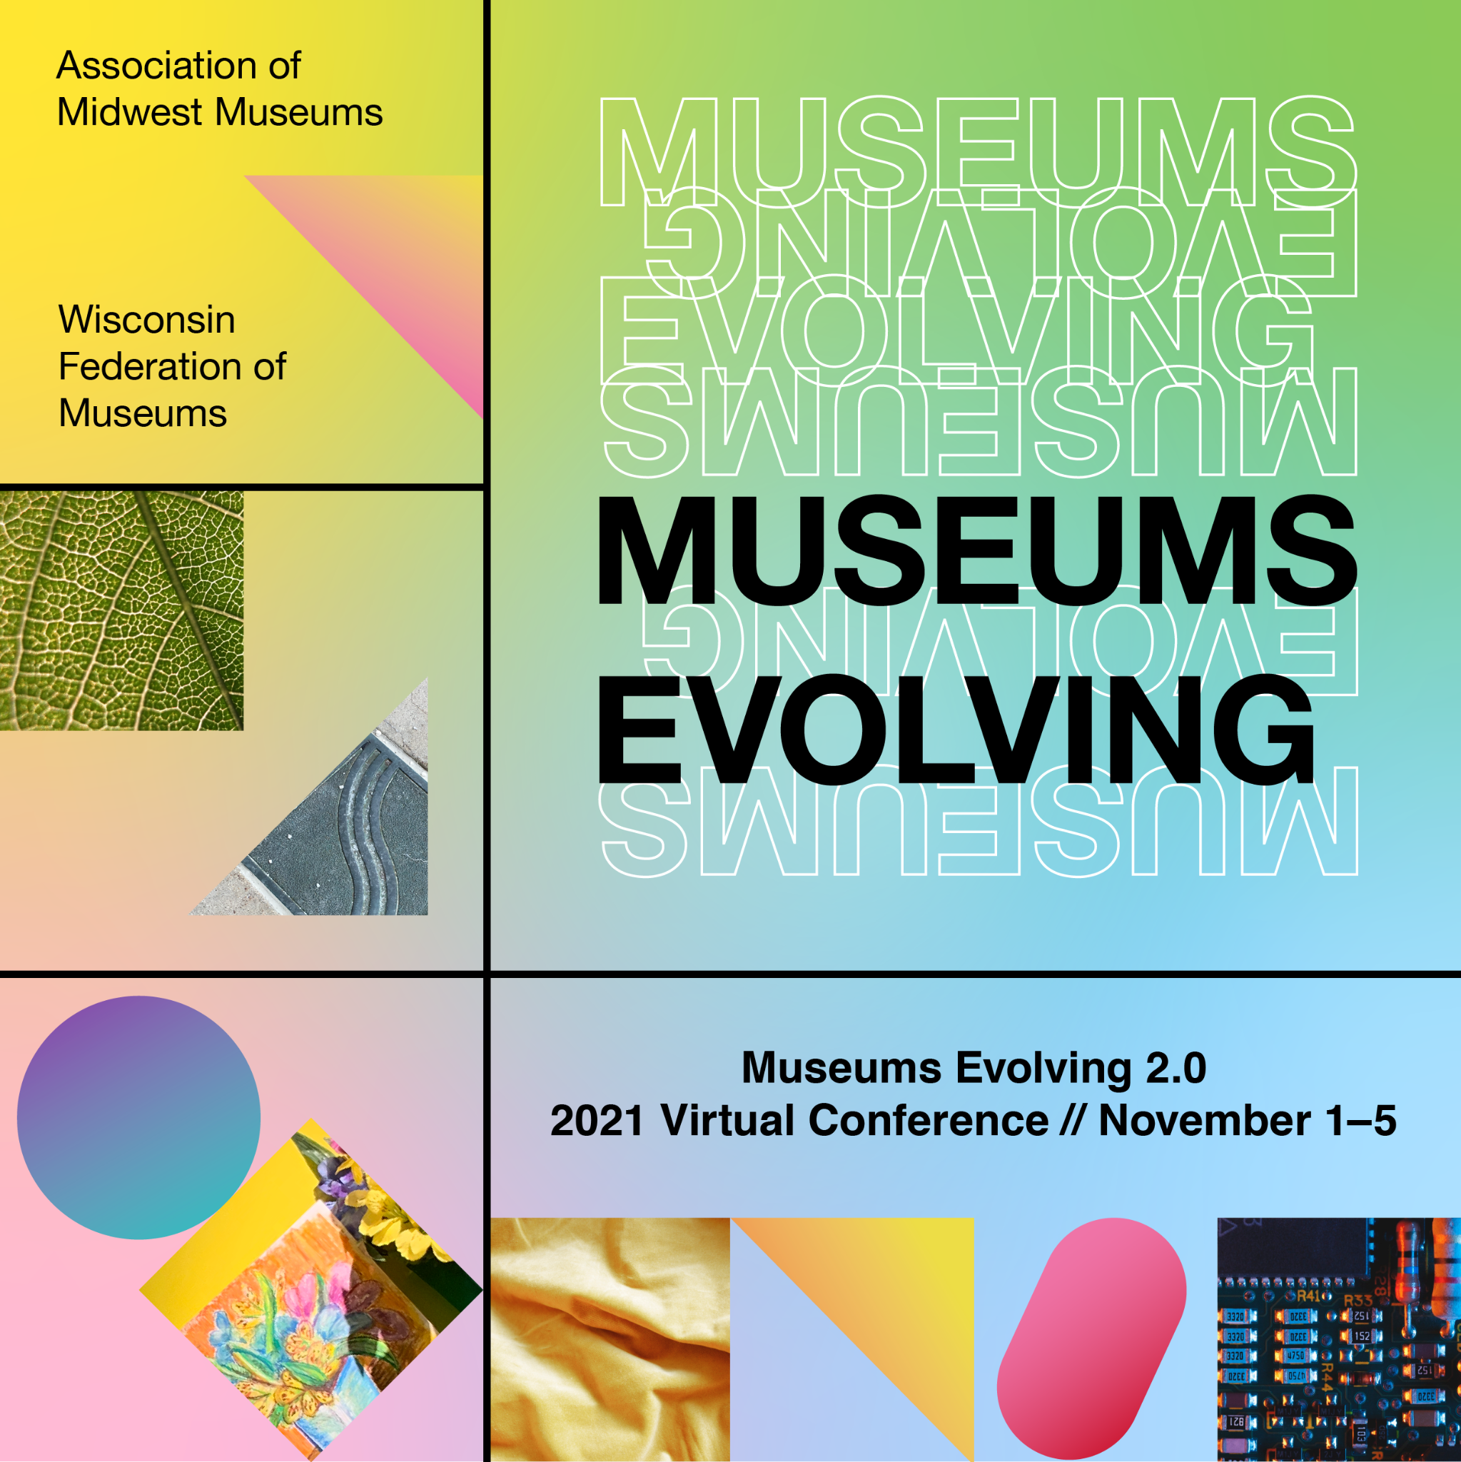

Call for Session Proposals

Museums Evolving 2.0
2021 Virtual Conference // November 1-5
ammconference.org
-Deadline: July 2, 2021-

About the Conference
Earlier this year, the Association of Midwest Museums and Wisconsin Federation of Museums announced plans to go virtual for 2021, shifting our joint Milwaukee conference to 2022, to better address the current needs of museum hosts and members.

Museums Evolving 2.0, our 2021 Virtual Conference, will be all-virtual and flexible, with both on-demand and live opportunities. The program will include access to 40-50 pre-recorded breakout sessions made available before and after the live event for learning at your own pace. The live experience will take place November 1-5, and be centered around the peer-to-peer exchange we look forward to at conferences—plus inspirational talks, networking activities, and opportunities for Q&A with breakout session presenters. You’ll also have access to a virtual expo highlighting new exhibitions, behind-the scenes tours, product demos, and a myriad of other projects from Midwest museums and service providers.

About the Theme
Over the past year we watched the theme for our joint conference, “Museums Evolving,” find new meaning. Sparked by a global pandemic, museums ventured into uncharted digital media and technology territory. In response to civil unrest around racism and police brutality in America, many museums are evaluating their role in civic discourse while answering a renewed call to action for diversity, equity, access, and inclusion in the profession.

Pandemic or not, the world is constantly changing—culturally, technologically, and economically—and cultural and heritage institutions are responding. Museums Evolving 2.0 will explore the evolutions that were already taking place in our profession pre-pandemic, when we first considered this theme, and the ways in which the (good) disruptions of 2020 and 2021 have fanned the flames of change.

How are museum missions, programs, exhibitions, collections, practices and policies evolving and what future trends do we see? How does a museum sustain relevancy in a changing world and profession?

We invite members of our museum community to propose sessions that lead and engage others in discussions about the evolution of museums, produce solutions to common challenges, and support advancements in our field. We welcome proposals that explore how museums have changed, and how they will continue to do so as their communities become the center of everything they create and share with their audiences.

Propose a Session
Keep in mind: Breakout sessions will be pre-recorded and made available to participants via a session library. Sessions will be 30-45 minutes. Attendees will have the opportunity to ask presenters questions during live Q&A sessions on Thursday, November 4, 2021.

We are seeking session proposals that address the following topics:
- Accessibility, Diversity, and Inclusion: What are projects that moved the needle?
- Collections: How has the past year influenced collections practices - digitization, decolonization, accession and deaccession, preservation and conservation?
- Climate change/justice and environmental sustainability: What’s our role now?
- Disaster Preparedness: What lessons should be carried over into our plans?
- Exhibitions: How are museums creating virtual or in-person interactive experiences on limited budgets? What are new trends in label writing and content development?
- Evaluation: How are museums measuring success for virtual offerings? How are audiences being engaged in front-end and formative planning?
- Funding: What new models and strategies have been employed during the pandemic for programs, retail, events and rentals, and other sources of earned revenue?
- Fundraising: What’s the current landscape of philanthropy? How are museums engaging donors and communicating their missions differently?
- Leadership: How are museum leaders empowering staff at different levels, succession planning, and revitalizing and diversifying governance?
- Marketing and Social Media: How are museums connecting with their audiences now? What experiments worked during the pandemic - and what didn’t?
- Programs: What are our key takeaways from the pandemic? Who are museums reaching through programs now?
- Social Justice: How are museums engaging in civics and social justice on a local level? How have museums re-interpreted controversial/problematic exhibits, objects or artworks, or engaged communities in dialog?
- Workforce Development: What does it mean to be a “museum professional” now, from volunteers and interns to CEOs and boards? How are employee recruitment, retention, training, mentoring, and development evolving? How are museums addressing pay disparities? How are museums attracting more diverse candidates?

A few tips:
- We suggest proposing sessions that offer practical, scalable solutions and strategies.
- We encourage you to consider providing tools, templates, and resources for attendees. We’ll also provide a copy of your presentation slides.
- Sessions with careful thought given to the lineup of presenters and reflecting the diversity of our museum community (museum types and sizes, geography, race and ethnicity, etc.) are preferred.

Selection Criteria
Proposals are evaluated by museum professionals serving on the Conference Program Committee. During a blind review process, they will be looking for:

- Relevance to professional development needs in the industry
- Clarity of content and learning objectives
- Diversity of perspectives and presenters
- Practical and relevant examples and how to apply them in multiple settings
- Relevance to the conference theme (ideal, but not required)

The program committee reserves the right to make suggestions to improve proposals. This might include adding or changing speakers, expanding your topic to include other examples, or merging your session with one that is similar. This is done in an effort to provide the best overall line-up for conference attendees.

How to Submit a Proposal
Proposals must be submitted using the online submission form by July 2, 2021. For proposals to be considered, all fields must be filled in completely.

Presenters must be confirmed at the time of submission. If your session is selected for the program, all presenters must be available to participate in live Q&A sessions taking place on Thursday, November 4, 2021.

Here is an outline of the session proposal form to guide you:

Session Chair Information
Full name, organization, address, email, and phone information.
Session Chairs are responsible for organizing the session and relaying session information. Communications will come from admin@midwestmuseums.org.

Presenter Information
List of presenters, including full name, organization, and email address of each presenter. In addition to the Session Chair, you may have a maximum of 3 presenters/panelists. Presenters may be a mix of museum professionals, students, and service providers. At least ONE museum representative must be on your panel.

Session or Workshop Title
20 words maximum. Suggest a catchy, descriptive title.

Intended Audience
- Select your session’s intended audience(s). (Descriptions on page 8)

Session Track
- Select a track most closely aligned with your session’s focus. (Descriptions on page 9)

Proposal Narrative
500 words maximum. Share a detailed description of the focus of your session. Be clear and concise, and fully describe the point of your session. Connections to the conference theme are a plus. Be clear about the relevance of your content to a diverse range of audience members (different roles, disciplines, museum types, etc.).

Learning Outcomes
100 words maximum. This should be a short list that captures what participants will gain as a result of your session.

What will attendees learn or accomplish during the session or workshop?

Promotional Description
50 words maximum. Provide a short, punchy description of your session that can be used in conference promotions.

Presenter Agreement
Session Chairs must agree to the following terms when submitting the proposal:

- It is my responsibility as session chair to communicate all logistical and other information to session presenters.
- Our presenters will not use the session as a platform for promoting products or services.
- Our presenters are confirmed and available to participate in live Q&A on November 4, 2021.
- Our presenters understand that we may be asked to share session materials and resources and are open to the request.
- Our presenters agree to abide by the conference Code of Conduct.

Intended Audience
We’re asking that presenters identify their intended audience for sessions. You’ll find the following descriptors in the online form. Select all that apply to your session or workshop.

- Beginner - professionals or students with little to no experience with the topic
- Intermediate - professionals with limited experience with the topic
- Advanced - professionals with extensive experience with the topic
- Emerging Professionals - students or professionals who have worked in museums or similar organizations for fewer than 10 years
- Mid-Career Professionals - individuals who have worked in museums or similar organizations for approximately 11-30 years
- Late-Career Professionals - individuals who have worked in museums or similar organizations for an extended period of time and may be approaching retirement in the next 10 years

Session Tracks
Below are examples of topics that fall within each thematic session track. Choose the track that most closely relates to the focus of your session.

- Community Engagement & Partnerships: projects that engage other community organizations, community programs, outreach, access, volunteer recruitment, and measuring success of these initiatives/programs

- Collections Stewardship: accession and deaccession practices and policies, decolonization work, NAGPRA, cataloging and collections management systems, care and conservation, digital/physical conservation and preservation, collections assessments; ethical and legal issues relating to collections, and disaster preparedness

- Fundraising & Finance: earned revenue strategies, financial sustainability, financial models, general accounting/budgeting, fundraising strategies, membership models, corporate philanthropy and partnerships, strategic financial planning, and advocacy

- Education & Programs: virtual or in-person programs for schools, children/families, adults, and other audiences; actor-interpretation or museum theater; educational technology; program accessibility and inclusion; interpretive planning and design; program evaluation and assessment

- In-Gallery & Virtual Exhibitions: in-gallery and virtual exhibitions, content development, accessibility and universal design, exhibition evaluation and prototyping, interactive media development, graphic design, project management, fabrication and production, label writing and editing, and universal design and accessibility

- Leadership, Management & Equity: management and administration, leadership techniques and philosophies, staff development and succession planning, operations and infrastructure, salary/wage transparency and equity, museum worker unionization, recruiting and supporting a diverse staff, risk and crisis management, board development and management, strategic planning, building organizational culture, and internal-focused cultural competency and DEAI (IDEA) initiatives

- Marketing & Digital Media: marketing and external relations, websites, social media, communications strategies, marketing and digital media evaluation and assessment, mobile guides/applications, analytics and evaluation strategies

Proposals must be submitted using the online submission form by Friday, July 2, 2021.

