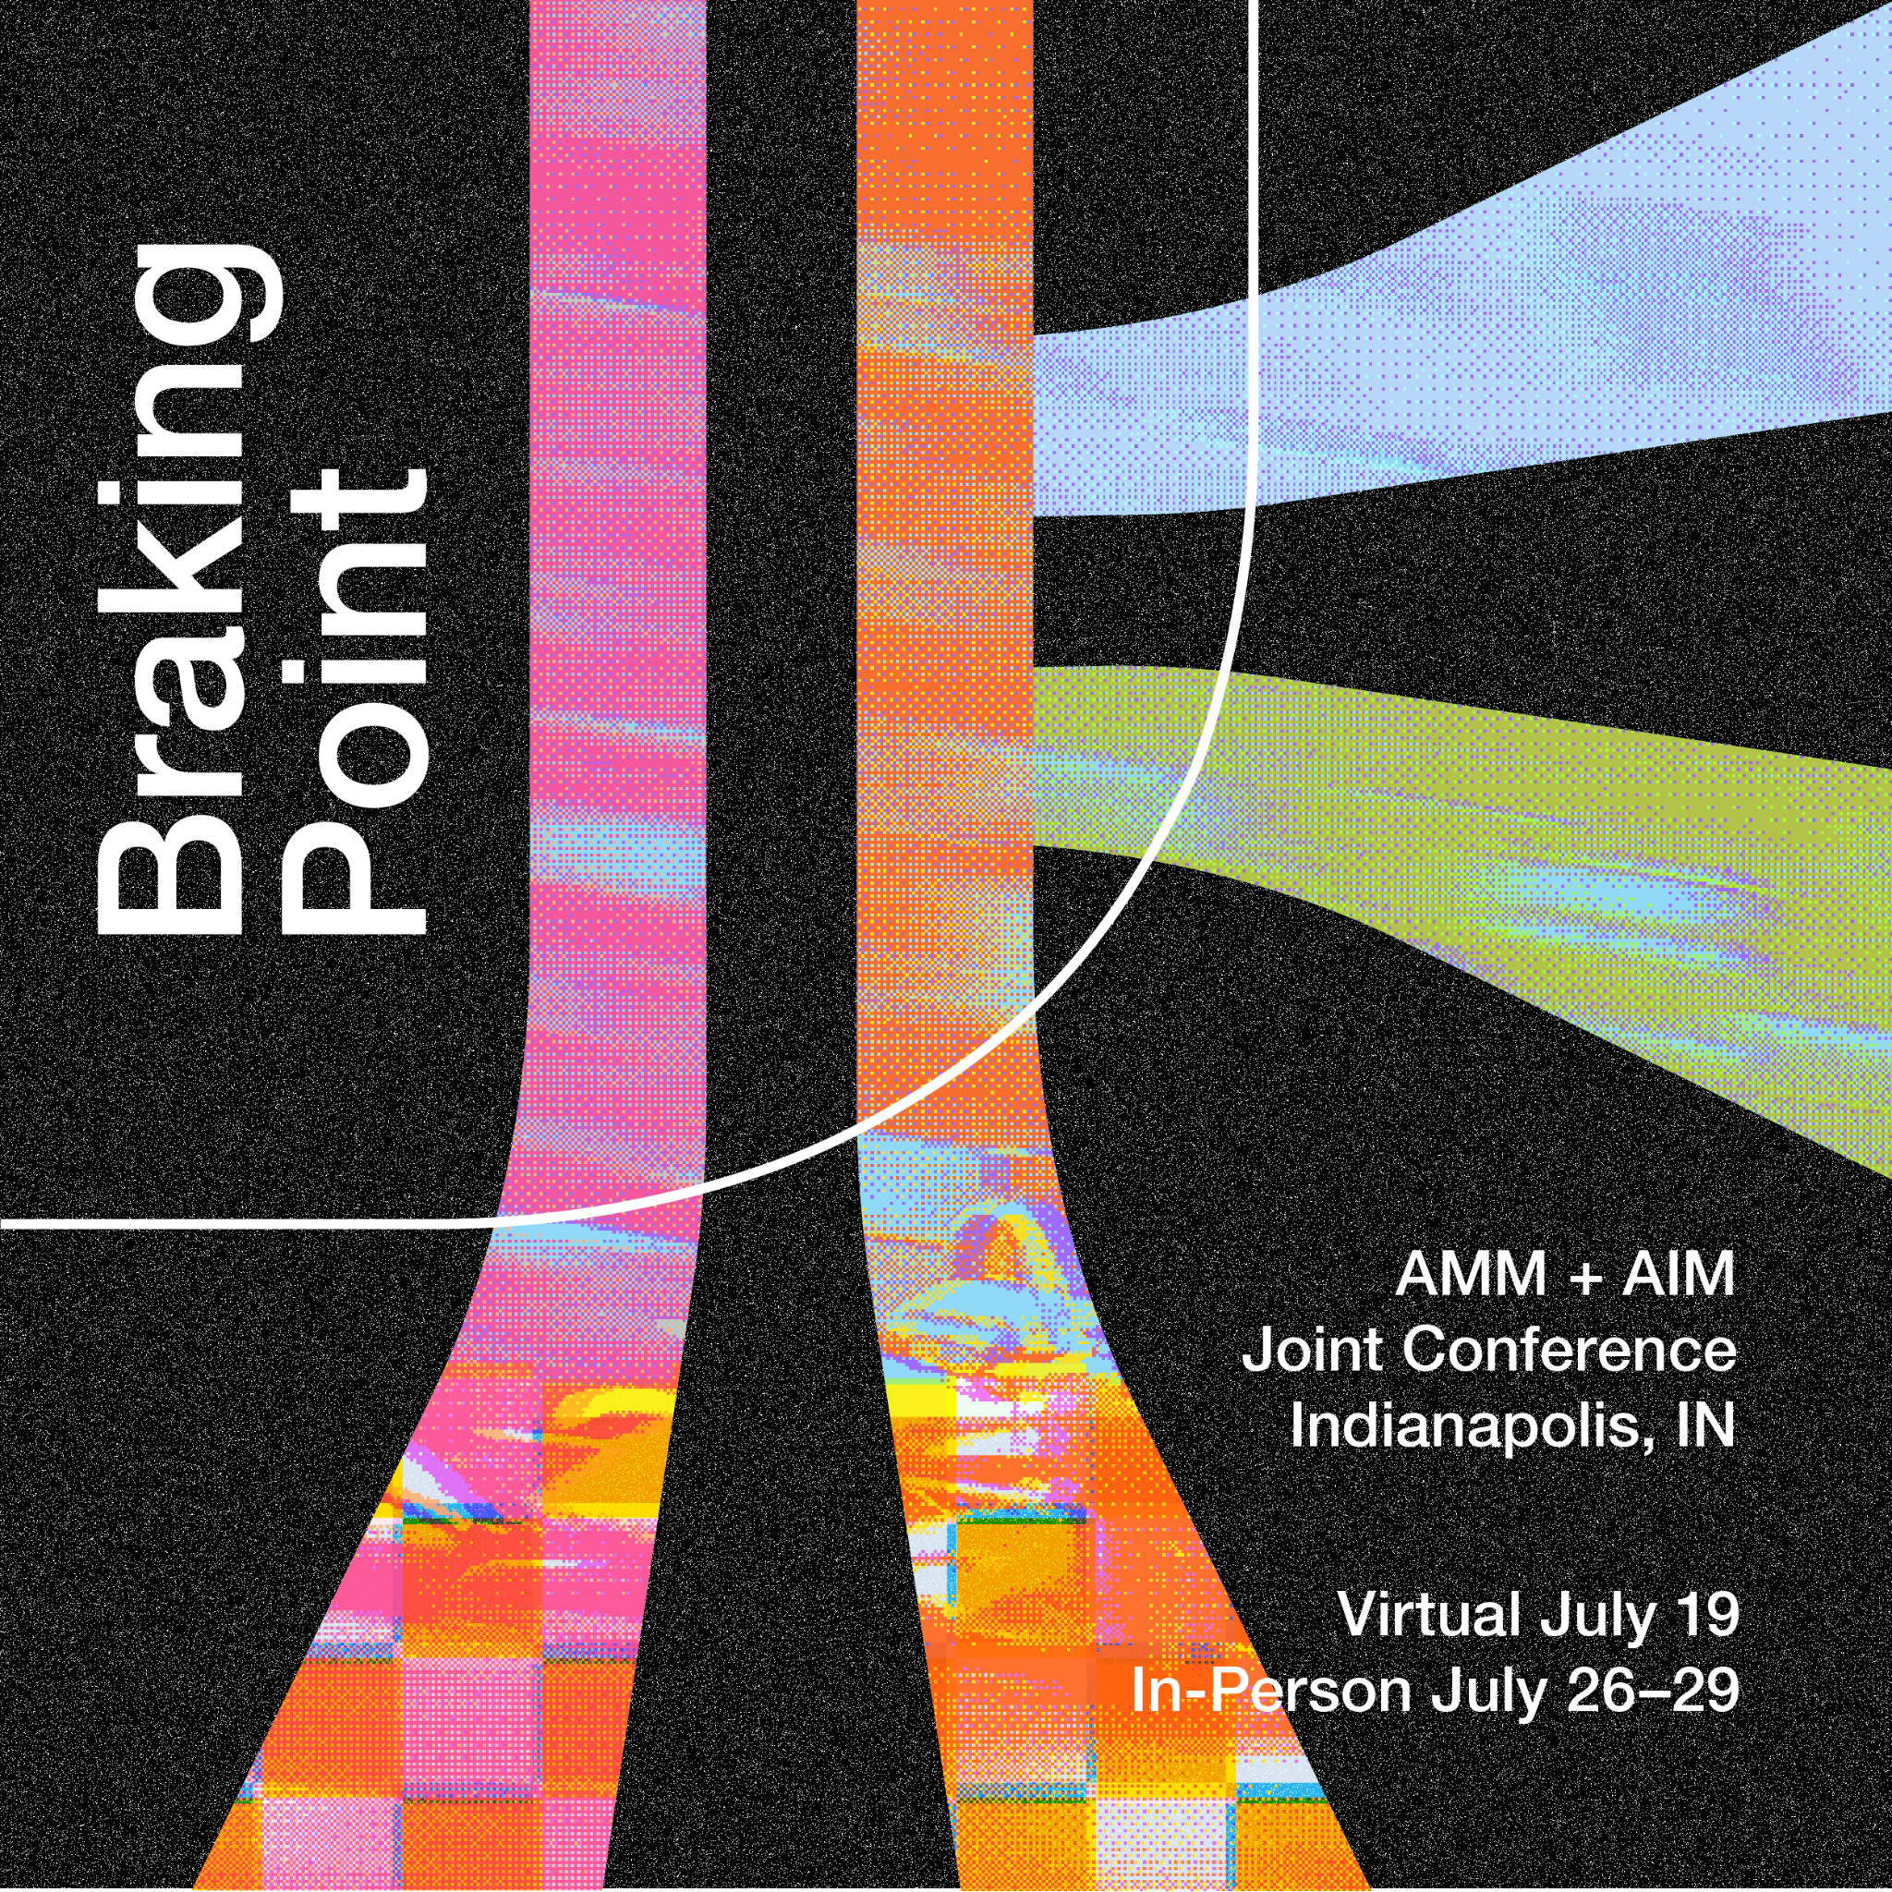

2023 Conference Guide

Contents
Arrival 2
Air 2
Train 2
Car 3
Public Transportation 3
Getting to the Conference 4
General Accessibility 6
Quiet Space 7
Nursing Space 7
Mentoring for First-Time Attendees 7
Virtual Platform/Mobile App 7
Conference Activities 8
Virtual Day Sessions and Activities 8
In-Person Registration 8
In-Person Keynote and Flash Talks 9
In-Person Sessions 10
In-Person Networking 11
In-Person Workshops and Tours 11
In-Person Museum Events 12
Post-Conference Retreat 12
Exhibits 13
Experiencing Indianapolis 14
After the Conference 15

Arrival
Union Station is located conveniently in the center of Indianapolis. There are a number of ways to get to the city and station depending on what is the most comfortable travel method for you.

Air
Indianapolis International Airport offers numerous daily flights. Located west of Indianapolis, it is a 14 minute drive, or about an hour via bus, with a direct bus connection or single transfer, depending on how much walking you are comfortable with.

Train
Union Station continues to host passenger rail to this day. The Cardinal, an Amtrak long distance train, travels in eastbound from Chicago on Tuesday, Thursday, and Saturday with scheduled arrivals at about 11:59 PM, and westbound from New York City, Cincinnati, and Washington, DC, with scheduled arrivals at about 5:15 AM on Monday, Thursday, and Saturday. The station is also home to Indianapolis’ Greyhound station. Union Station’s train station is not connected to the hotel, and is a short walk north, crossing under the railroad tracks to reach the hotel.
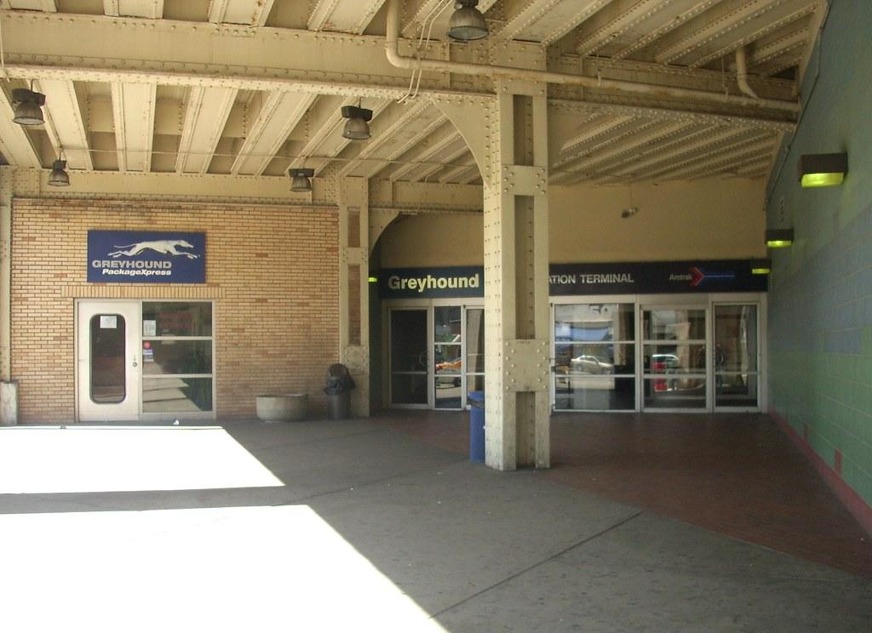

Car
Work is being done on the I-65 and I-70 split. From the east or west, the easiest way to get to the conference center is to take I-70 to exit 79, and follow directions for Illinois Street. From the north, take I-65 southbound to exit 114, for West Street, and head south, taking a left on Maryland Street. From there, take a right on Maryland Street to the hotel. From the South, merge onto I-70 West from I-65 North and follow the directions for east and westbound arrivals. The hotel offers valet service, and there are a number of parking structures nearby, the closest being the garage at Pan American Plaza.

Public Transportation
IndyGo, Indianapolis’ public transportation provider, offers bus service in Downtown Indianapolis. The nearest bus stops to the hotel and convention center are Pennsylvania St. and South Street, and Delaware Street and Louisiana Street, for buses 16 and 31. Transfers can be made to these lines at the nearby Carson Transit Center. IndyGo also offers paratransit service, as well as visitor status with application. For information on fares and trip planning, please see IndyGo’s website.

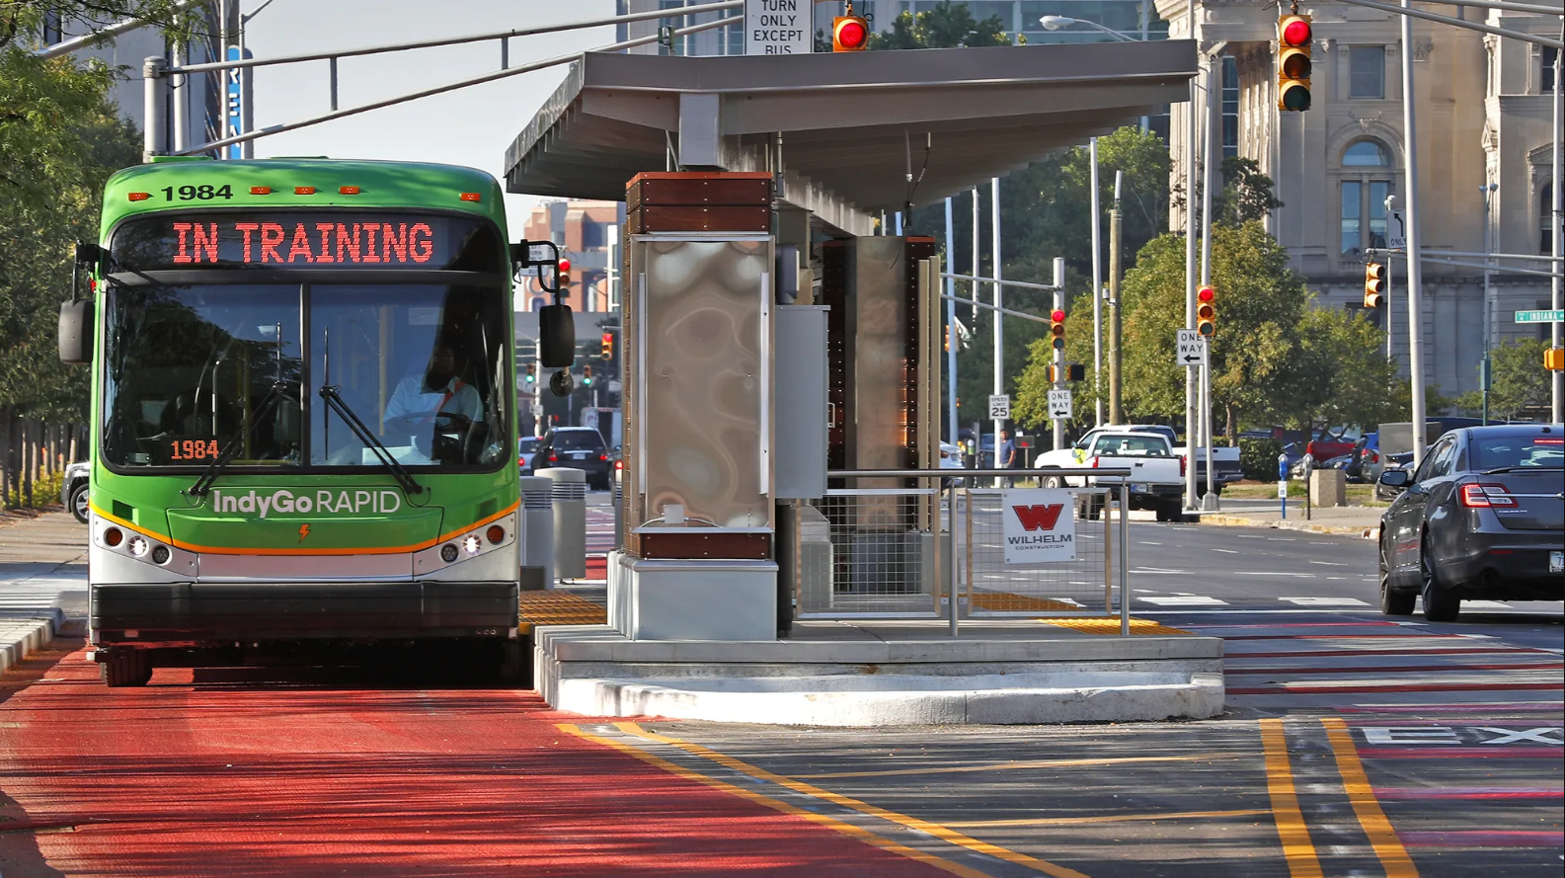

Getting to the Conference
There are a number of ways to get to the conference inside of Union Station.
For those driving, the easiest way is to enter from the main entrance to the hotel on Louisiana Street where valet parking is located. Enter and go past the main lobby and front desk to the elevators. Take the elevators up to the 2nd floor. There will be signs along this route to help indicate where to go.
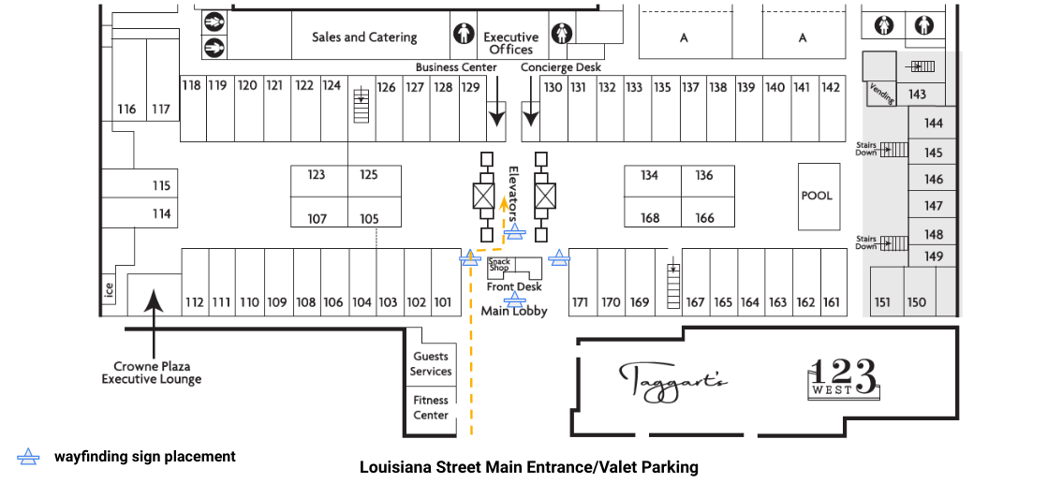

When you reach the 2nd floor, go towards the green passenger cars that have been turned into hotel rooms. There should be a sign indicating the direction of Union Station/Grand Hall, and the car should have “017” and “018” on it as well. Turn right, and follow the signs to the Grand Hall, past the Illinois Street Ballrooms.
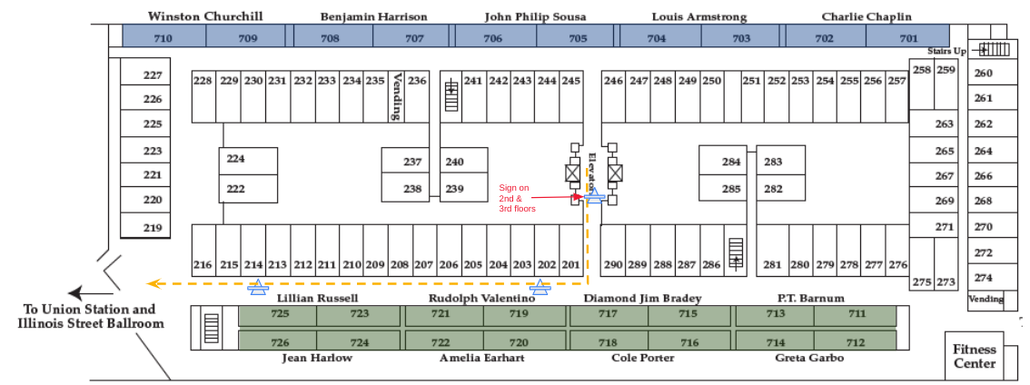

In the hallway area outside of the Illinois Street Ballrooms, you will see signs directing you to Union Station and the Braking Point conference. There will be both stairs and an elevator to take down to the conference areas in Union Station.
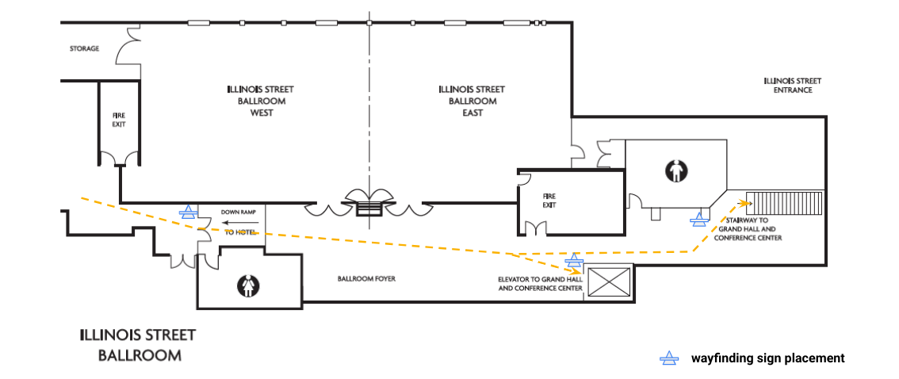

If you are not entering from the hotel, there are two entrances to Union Station event spaces on Illinois Street, underneath the elevated railroad tracks. The accessible entrance is marked with a sign. Take the short elevator ride to the main floor (marked “G” for Grand Hall). There is also a non-accessible entrance with multiple doors on Illinois Street, which has a steep ramp up into the Grand Hall Foyer.
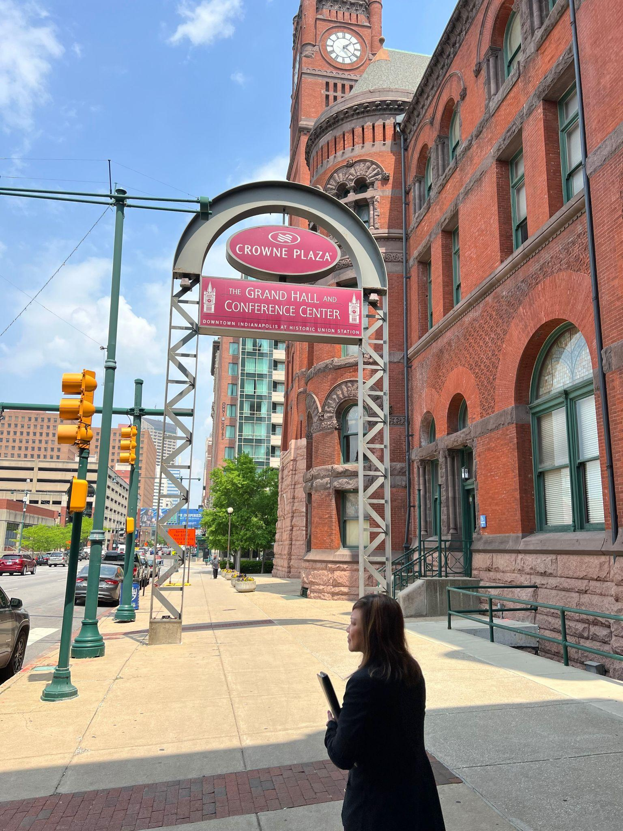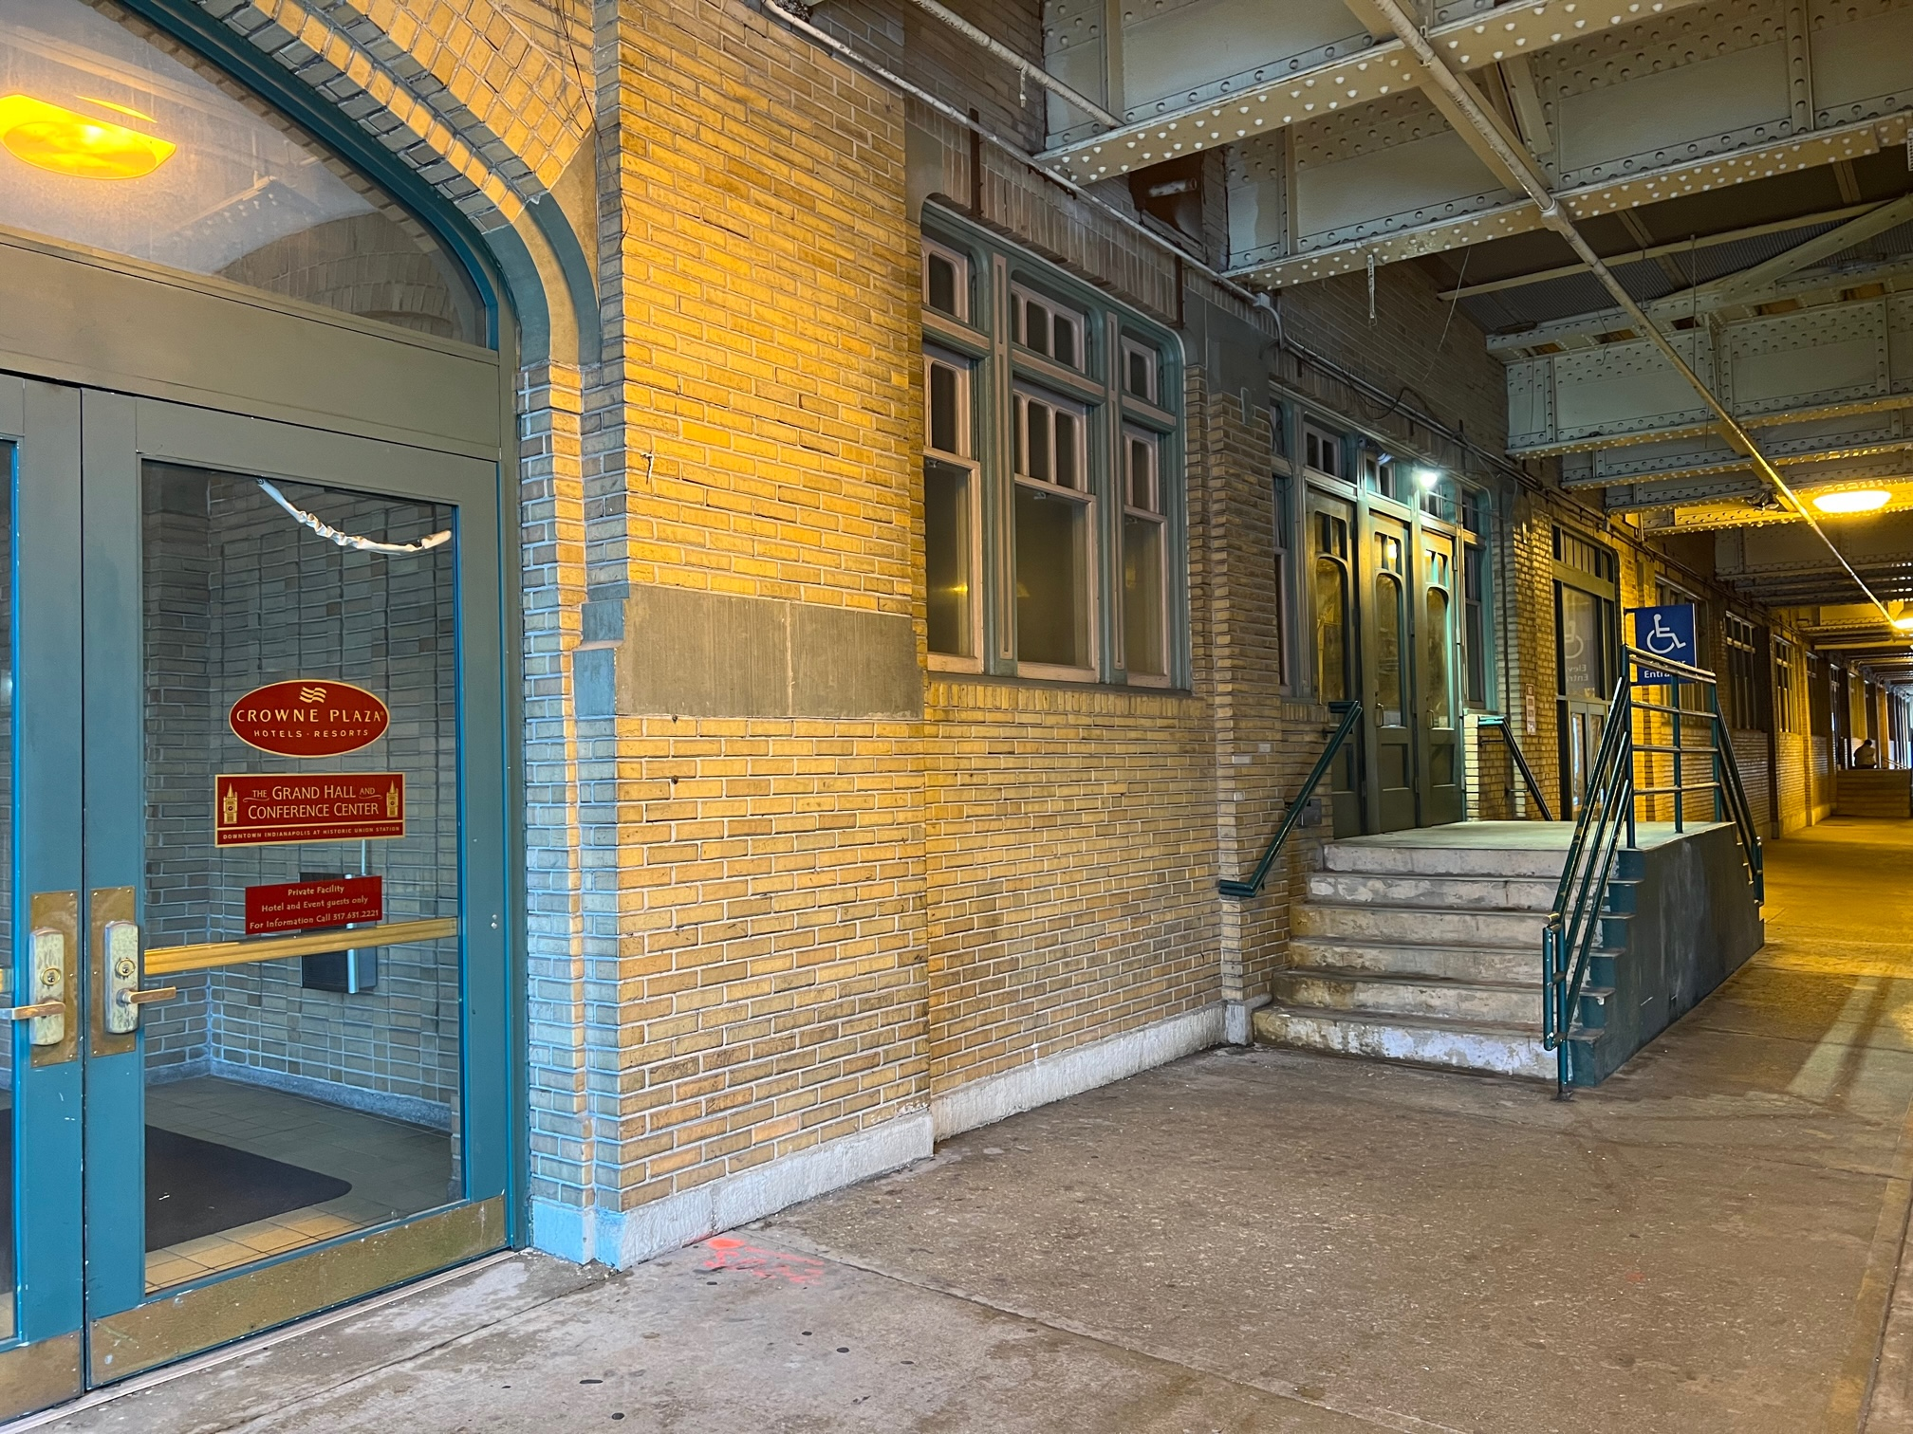

General Accessibility
While Historic Union Station may be a historic building and may therefore have some amenities that are not fully accessible, the Association of Midwest Museums has put great care into making sure that there are as few barriers as possible present at this conference. All spaces will have accessible routes, and assistive listening devices are available if requested. American Sign language interpretation will be provided for keynote and plenary sessions, as well as all online sessions, and for other sessions upon request. Please give us notice prior to the conference if you require ASL interpretation so we can best accommodate your needs. We will also have some spaces for specific kinds of supports, as outlined below.
If you have any accessibility needs that you want to make sure are supported, or have any questions about accessibility at the conference, please contact Ross Edelstein, the accessibility advisor for the conference, at redelste@iu.edu.

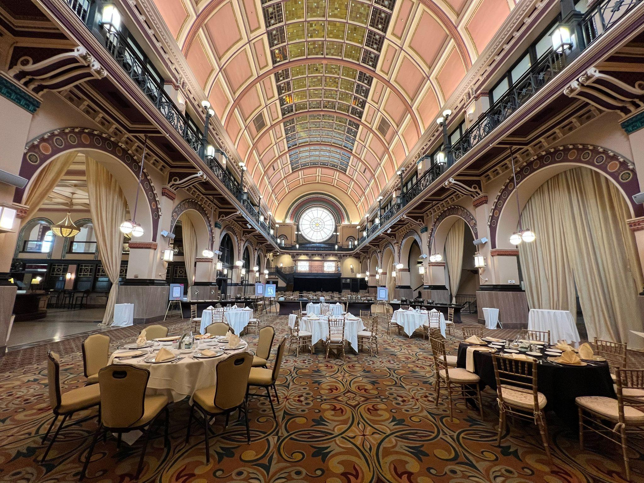

Quiet Space
This year, a quiet space will be provided at the conference. It will be in the Illinois Central room and will be marked with a sign on an easel. This space will provide tools such as stress balls, ear plugs, headphones, fidget tools, and light activities for participants. There will also be soft seating and tables. While all are welcome to this space, please remember to be respectful of others; this space is intended to be quieter, so please use headphones if others are in the space, and that others may be using the space to get away from the hubbub of the conference, and likely will want to be left alone.

Nursing Space
A nursing space, in the Erie Room, is also present. This single-occupancy space can be reserved at the onsite registration desk. There will be a table and some chairs in this space.

Mentoring for First-Time Attendees
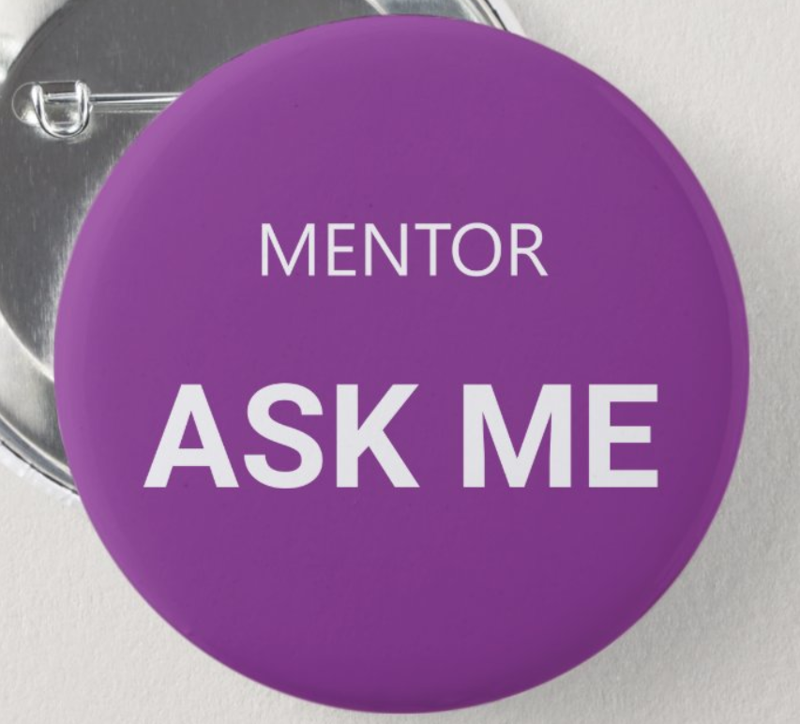
This year, we are happy to announce mentoring for first-time attendees at the conference! Through a virtual pre-conference meetup on July 7th, we will connect first-time attendees with peers with similar interests who have attended several AMM conferences. The goal is to set first-timers up for success by being a resource for questions about how to conference or how to navigate networking opportunities.
In addition, frequent conference-goers serving as mentors will wear buttons on their lanyards that say “ASK ME” making them easy to spot during in-person conference activities.
If you are new to conferencing and interested in attending the pre-conference virtual meetup in July, please complete the Zoom signup form linked here. If you have questions about this program, feel free to reach out to Ross Edelstein at redelste@iu.edu.

Virtual Platform/Mobile App
This year, attendees will use a platform called Whova to access the conference Virtual Day sessions and activities; plan their schedule for the in-person event; learn more about exhibitors; participate in discussion groups; send questions to conference organizers; and connect with fellow attendees before, during and after the conference.
Registered attendees will receive instructions via email from AMM/Whova for downloading the mobile app or accessing the event through a web browser.

Conference Activities
The conference is home to a number of different kinds of events and sessions.
The Virtual Day will take place on Wednesday, 7/19, and the in-person days of the conference are Wednesday, Thursday, and Friday, 7/26-7/28. There is also an optional retreat on Saturday, 7/29, at Conner Prairie.

Virtual Day Sessions and Activities
Virtual Day activities will take place virtually in Zoom Meeting or Zoom Webinar. There are three session blocks on the virtual day. A virtual museum tour will take place at the start and end of the day, and there are two hour-long networking activities between session blocks. In addition, AMM will be hosting its Annual Business Meeting briefly between the morning virtual tour and opening session to share announcements about elections and other member business. There will generally be about half an hour between each virtual activity to take a break.
Participants can self-select the sessions and activities they wish to attend during Virtual Day based on their interests. Virtual Day activities are casual, and attendees are invited to come as they are, from wherever they are, and participate as they are comfortable.
All virtual tours and sessions will have American sign language interpretation and captions. Interpretation for networking activities will be accommodated upon advance request during registration. Please contact Ross Edelstein, accessibility advisor for the conference, at redelste@iu.edu if you have any accessibility needs for these sessions.

In-Person Registration
Registration will open at different times on July 26-28 and will remain open until 5:00 p.m. each day. On Saturday, 7/29, registration will be open for one hour at 8:00-9:00 a.m. for questions.
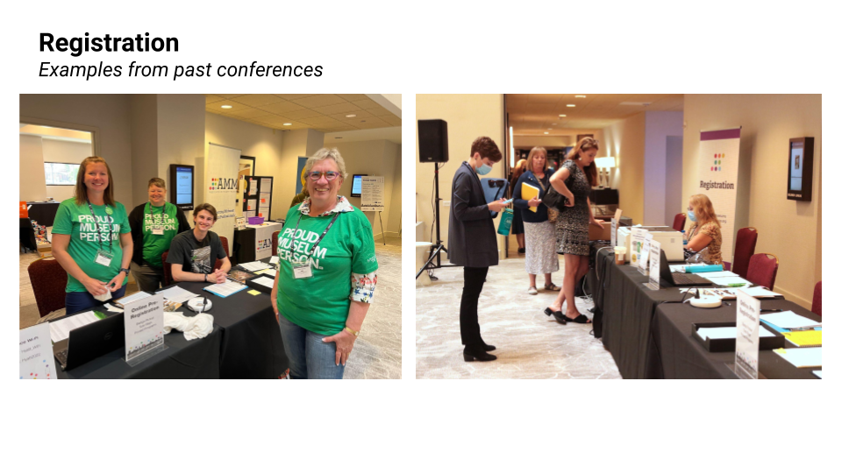

In-Person Keynote and Flash Talks
The Keynote session will be on Thursday, 7/27, at 10:00 AM, featuring a single guest speaker. The session will include a 30–40-minute presentation followed by question and answer, lasting approximately an hour. Flash Talks will take place on Friday, 7/28, at 10:00 AM, and will feature 5 short talks on a number of subjects. This session will also last approximately one hour.
Both of these general sessions will take place in the Grand Hall in Union Station. It may be loud, and some areas may be quieter. There will be American sign language interpretation, and assistive listening devices are available upon request.

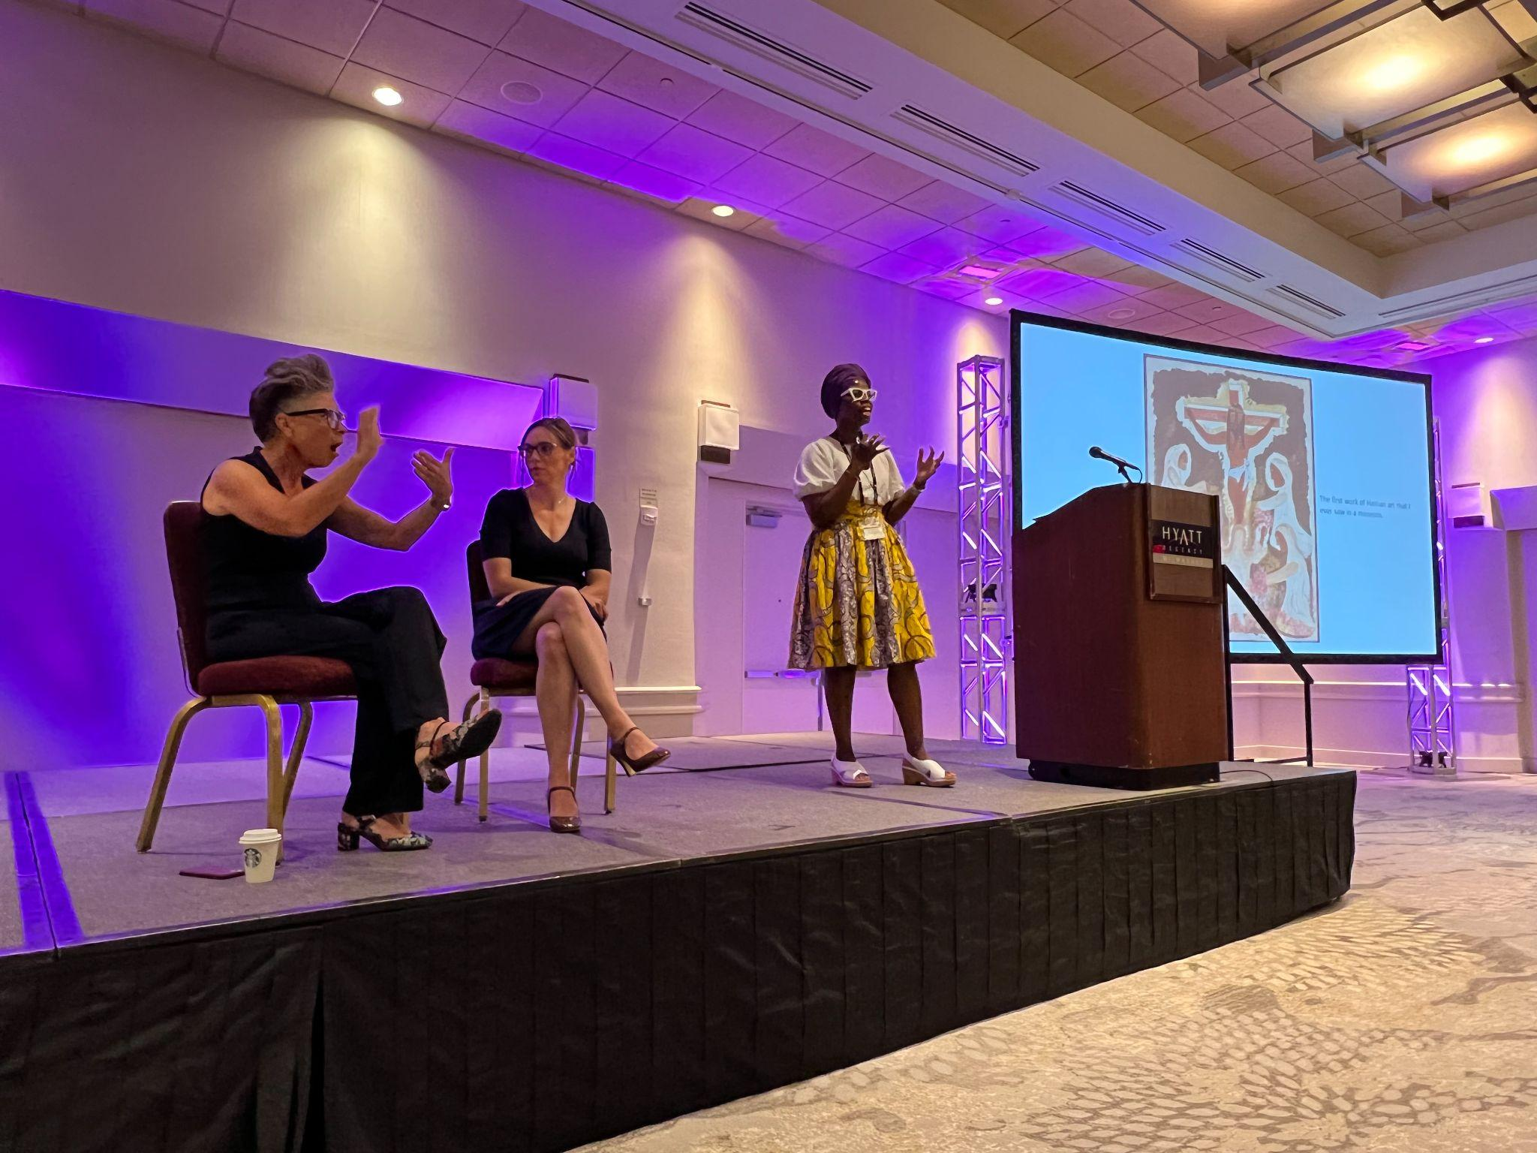

In-Person Sessions
On Thursday and Friday, there will be three blocks of concurrent breakout sessions (seven in each block). Attendees can choose what sessions they want to attend based on what their interests are. Sessions can have assistive listening devices and ASL interpretation on request. Each session lasts an hour.
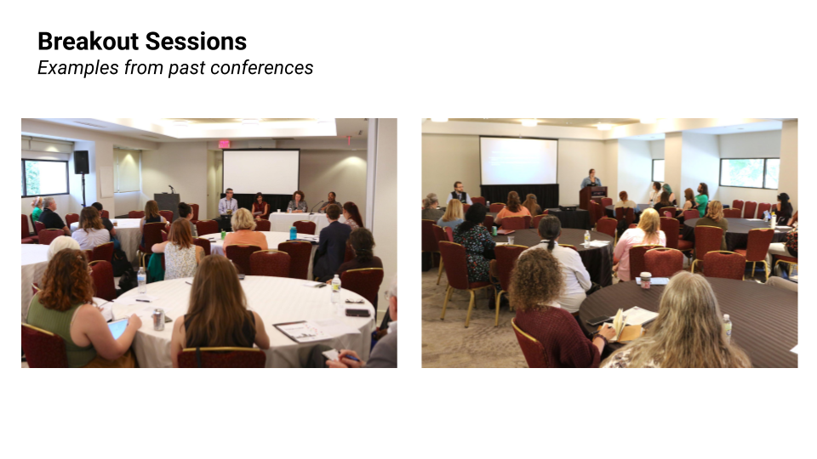

In-Person Networking
There are a number of networking opportunities, such as lunches and meetups. These are an excellent opportunity to meet others with similar interests to your own. While there may be some overlap in the timing of these activities, you are welcome to come and go as you please to experience multiple events!
Additionally, informal networking, such as dinners and small groups traveling together to offsite events, are often a part of conferences. Don’t be afraid to ask around and see what’s going on. Keep an eye on Whova, the conference app/platform, for impromptu meetups. Not only are these good ways to meet new people, but they can also help you explore Indianapolis!
When networking, don’t forget to share contact information; maintaining relationships with people after the conference is as important as developing them in the first place. If you do not have business cards, come with a pencil and paper to share contact information or swap information in the conference app/platform, Whova.
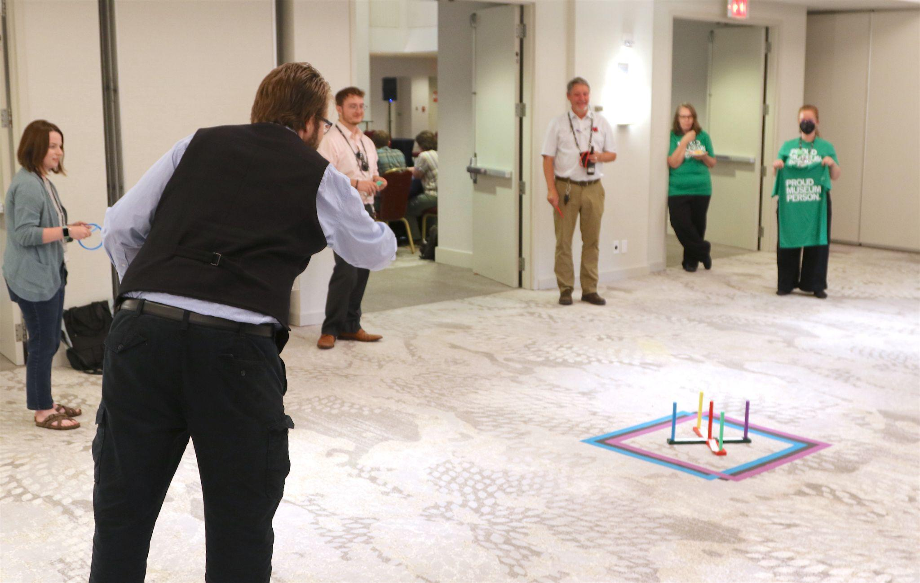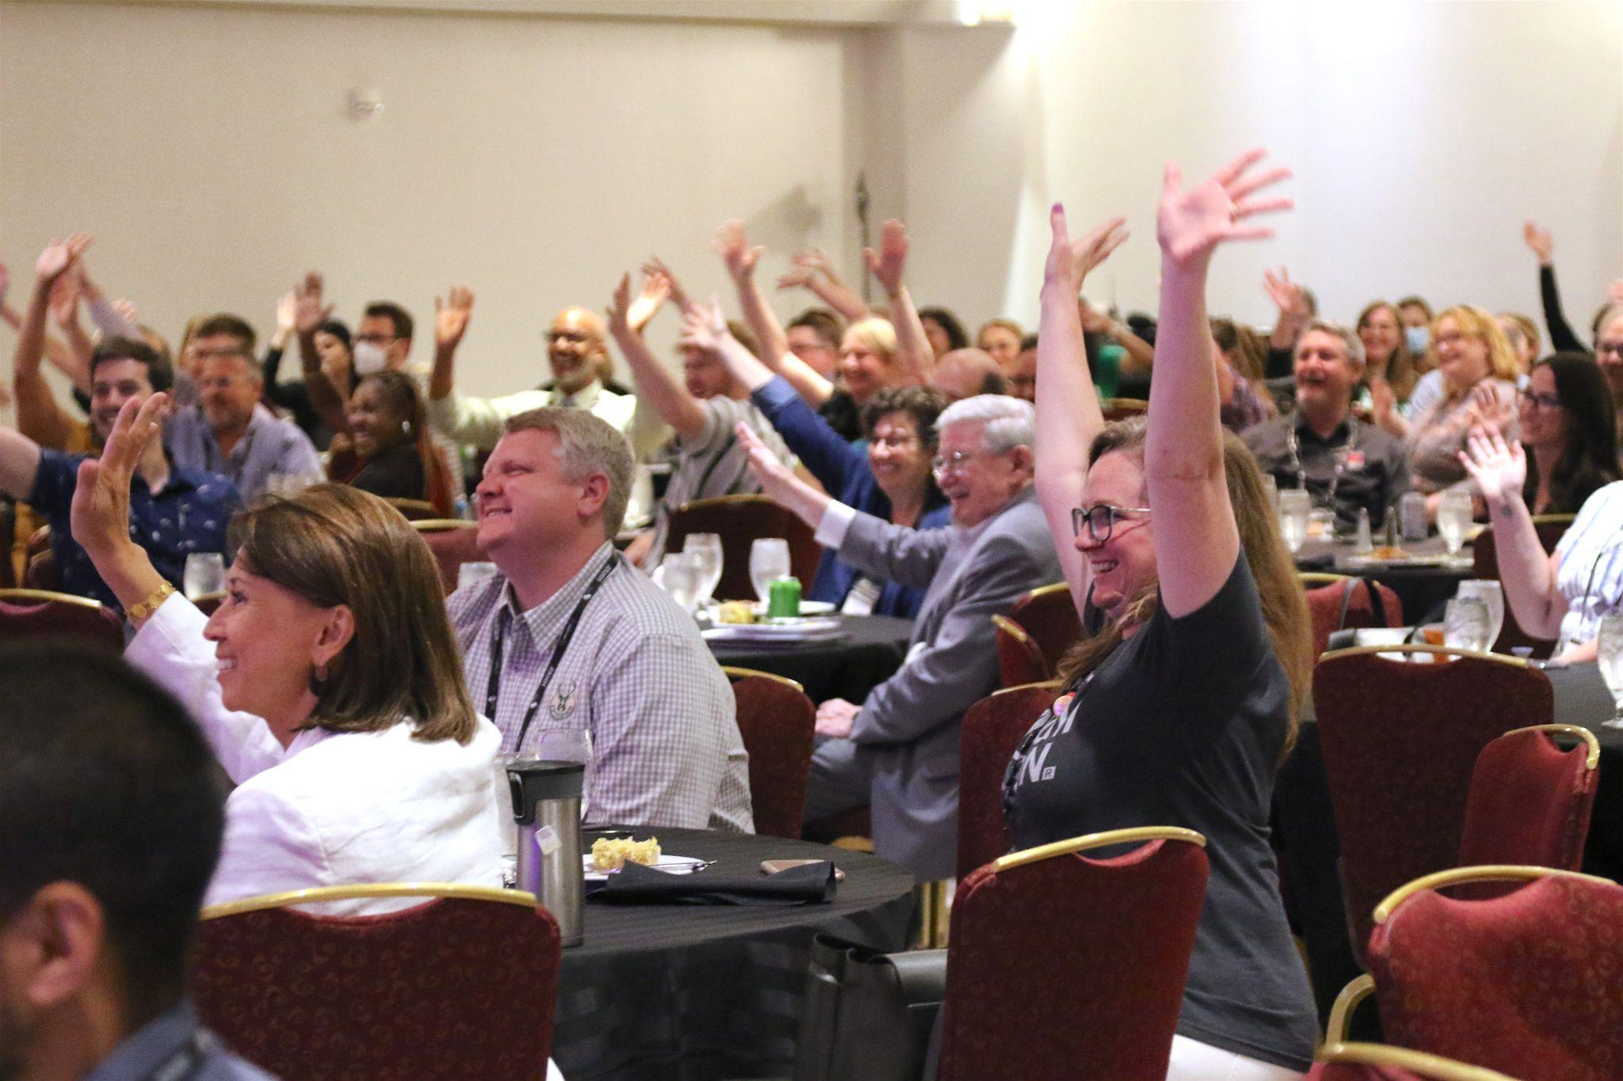

In-Person Workshops and Tours
There are a number of pre-conference workshops on Wednesday, 7/26. These will cover a number of topics and will be held at different museums in the city. See the conference website for more information on these workshops, as they do have an extra cost, and if you require any accessibility support, please contact Ross Edelstein, accessibility advisor for the conference, at redelste@iu.edu.
There will also be a number of tours before the conference. Much like the workshops, these are a great way to meet new people in the field with similar interests. They will be at several different museums in the city, feel free to go to the conference website to check out the tours and figure out where you are heading! For any accessibility support, reach out to Ross Edelstein, Accessibility advisor for the conference at redelste@iu.edu, and he can help get you in contact with any resources that you might need for these sites.

In-Person Museum Events
There are a number of offsite events held at different museums in the area. More information about these events can be found on the conference website. While they are entirely optional and require an additional ticket, they are a good way to network and get to know other attendees, as well as see different spaces in the city. Transportation is provided by the conference but, in many cases, attendees are welcome to drive or walk to the event locations.

Post-Conference Retreat
The free retreat after the conference, from 10:00 AM to 12:30 PM, will be at Conner Prairie. There are a number of things to do and see at this living history site, and you may choose to participate in retreat activities or explore the venue on your own.
Pre-registration is required to participate in retreat activities. Roundtrip transportation to Conner Prairie from the hotel will be provided by AMM for those registered. If attendees wish to explore Conner Prairie on their own, at their own schedule, they can present their conference badges at the front desk at the museum for free admission. Conner Prairie is an outdoor experience, so dress accordingly! Please see the conference website for more information on the retreat.
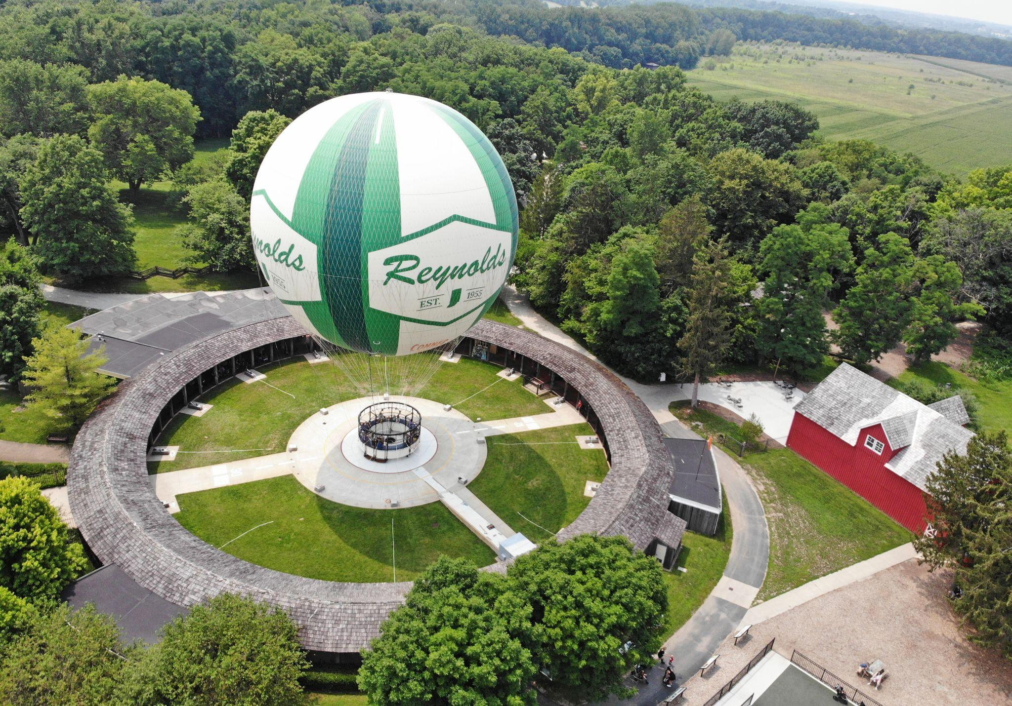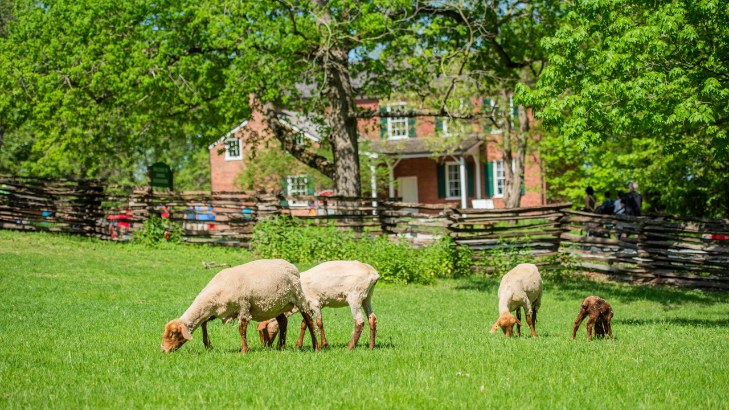

Exhibits
The conference also features exhibitors sharing their products and services. This is a good place to get to know the various service providers across the Midwest, especially if your organization is looking to hire someone. Exhibits are open both days of the main conference, from 9am to 6pm on Thursday, 7/27, and 9am to 2pm on Friday, 7/28. Exhibitors will also have pages in the virtual platform and conference app, Whova.
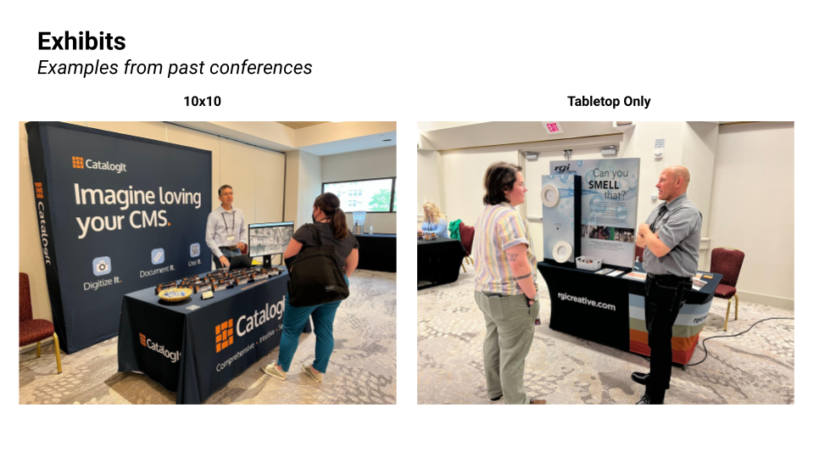

Experiencing Indianapolis
There are a number of things to do in Indianapolis. From sightseeing to the many museums in the city, to the parks and eateries, remember to make time for yourself. It’s ok to not attend every session block or event, as well. Make the experience yours. If you are planning on going offsite, remember to make a plan to get around the city, especially if it is your first time; the city is fairly spread out, so allow time to get around from place to place.

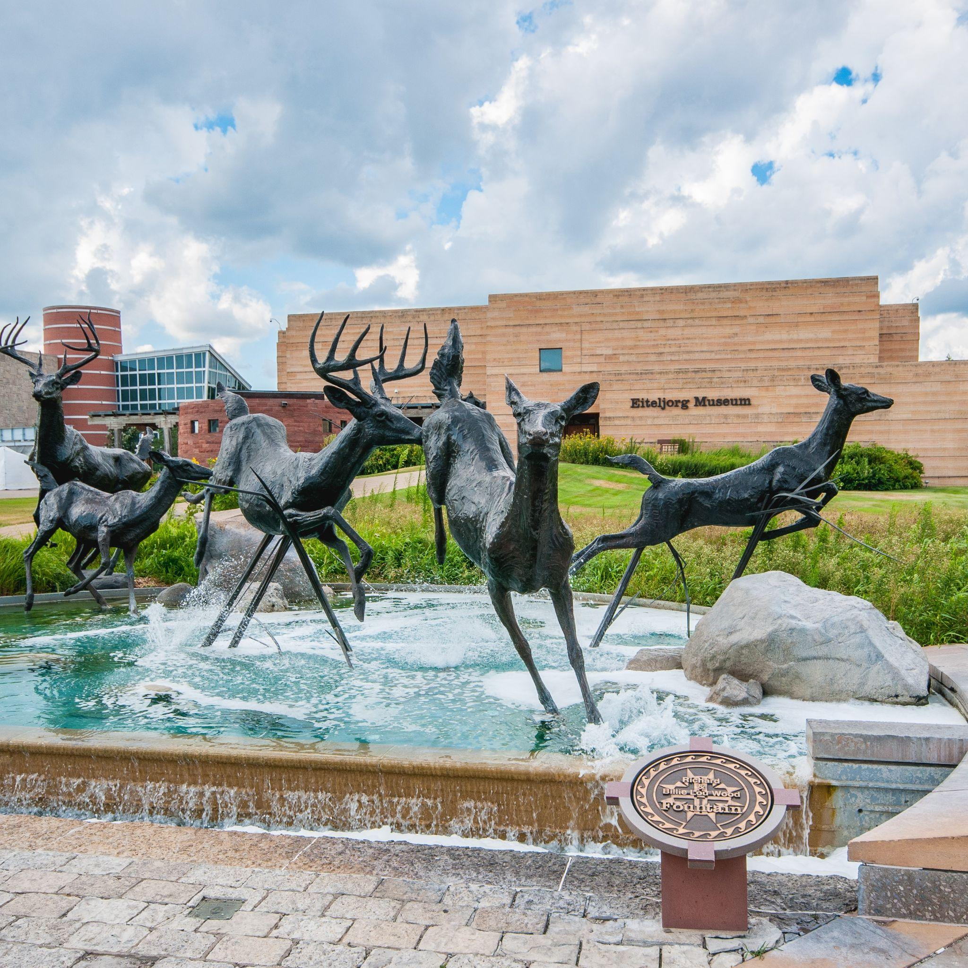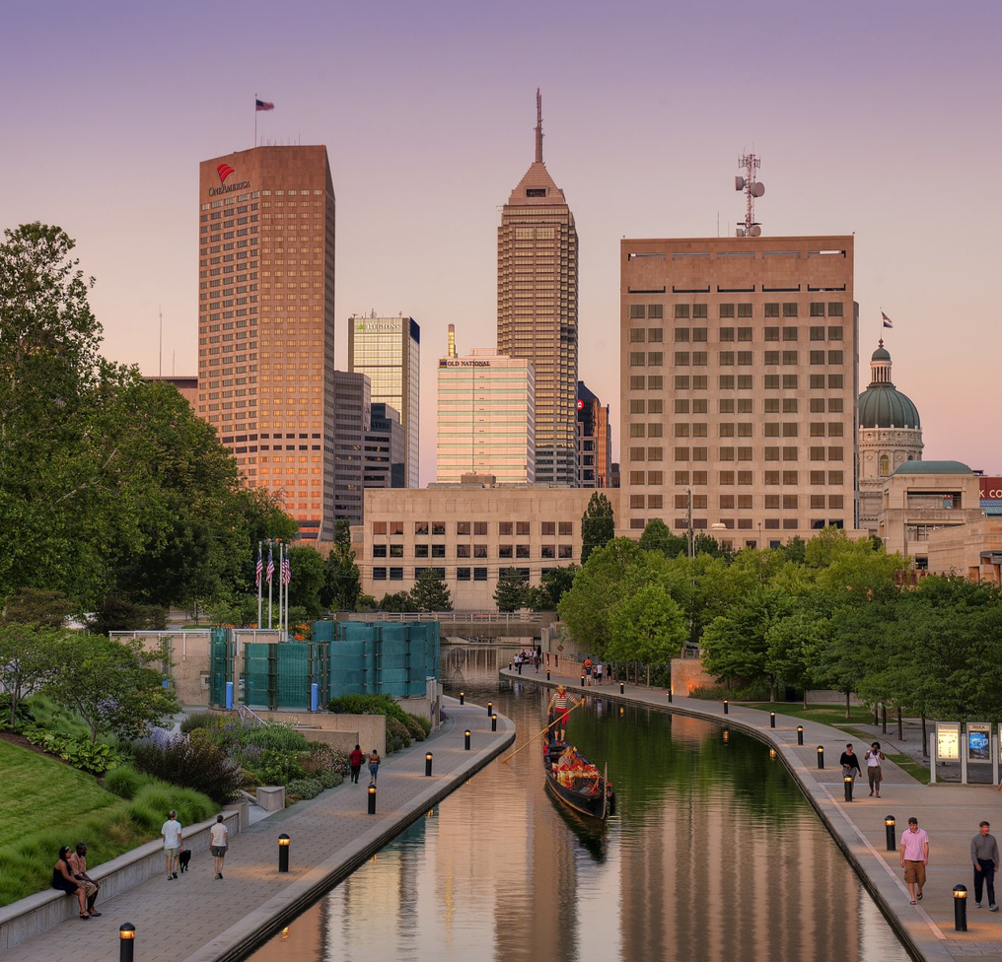
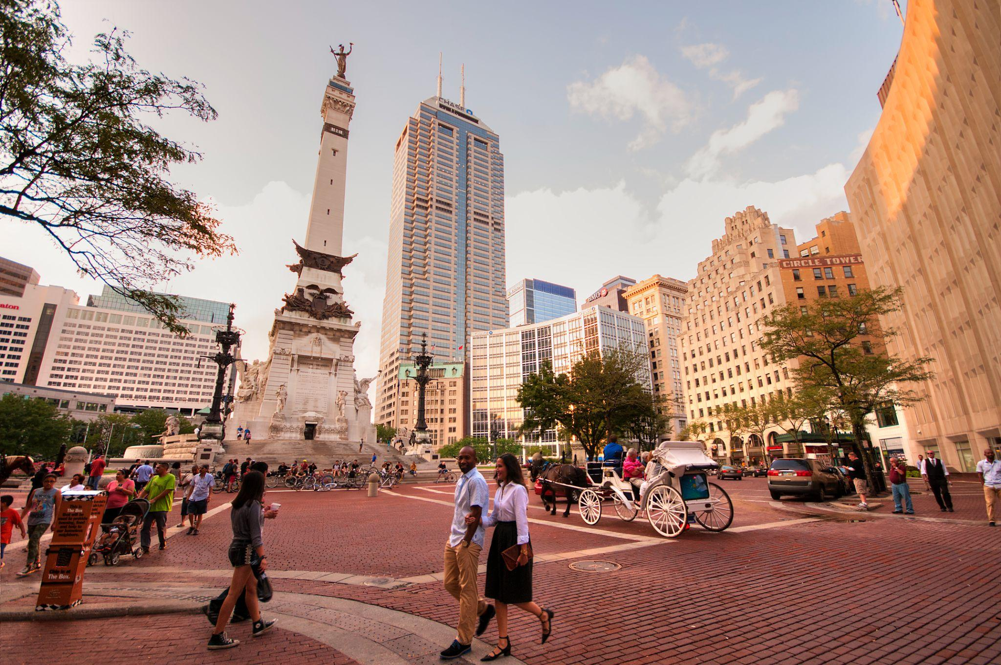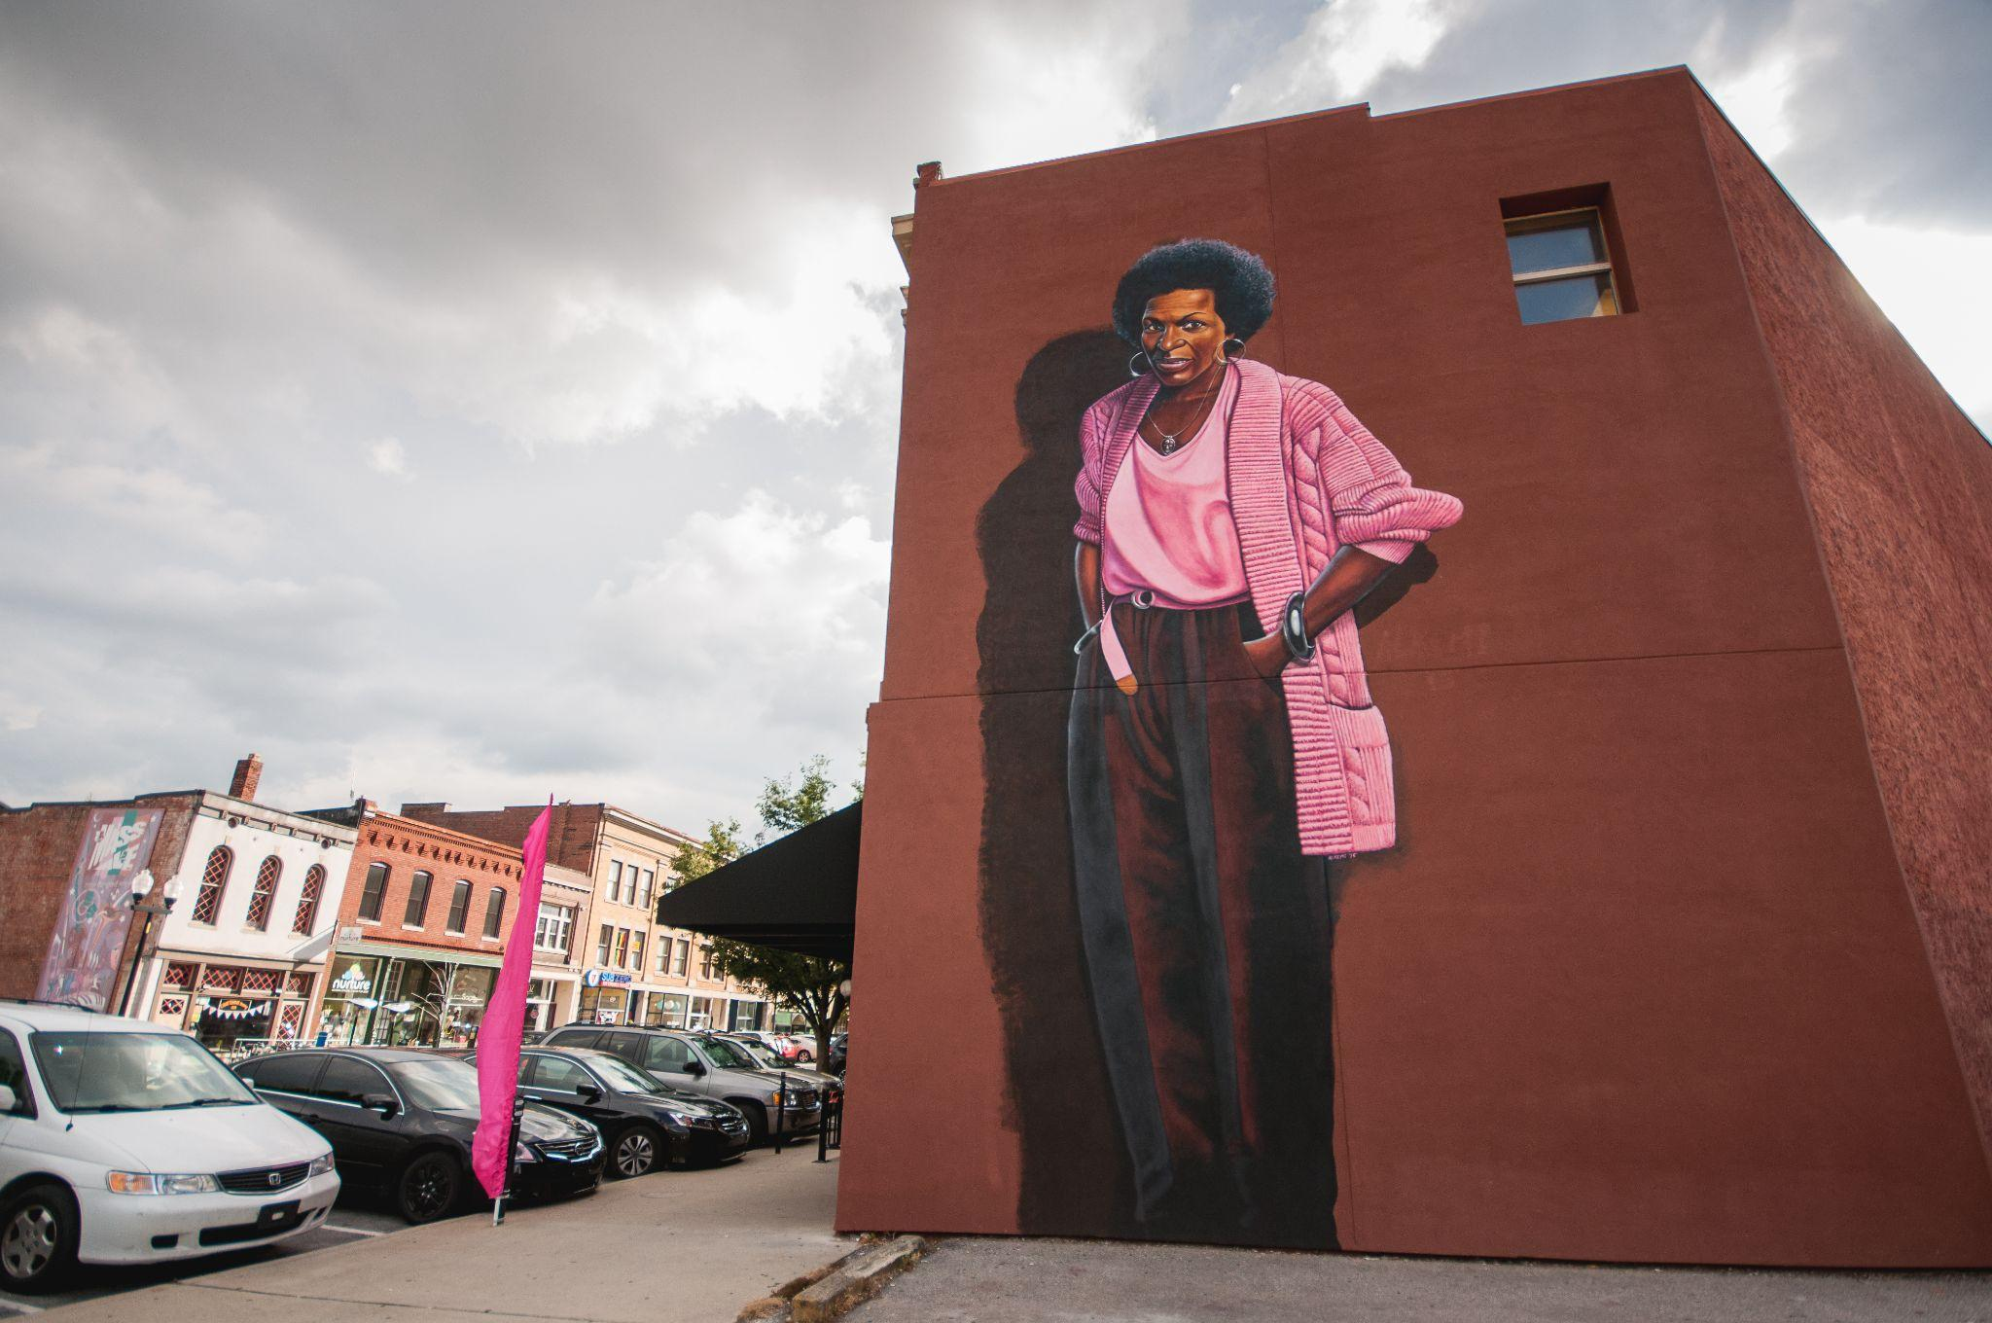

After the Conference
Leaving the city will be much like arrival. However, remember to keep your new contacts and reach out once you are home, and take time to digest all you’ve learned. Regardless of what you get out of the conference, make it yours. From all of us at the Association of Midwest Museums and the Association of Indiana Museums, we hope that you have a wonderful experience at the conference and look forward to seeing you!

